Super Mario Bros. X Gameplay Manual
Based on TheXTech Engine Version 1.3.6.1
Index
1. About The Game 1
1.A System Requirements - Suggested Requirements 2
1.B Controls 3
1.C Hotkeys 3
1.D Screen Layout 4
2. Game Features 6
2.A Characters 6
2.B Items 9
2.C Major Enemies 14
3. Copyright 15

1. About The Game
Original Game Platform created by Andrew Spinks 'Redigit'
Terraria official site = https://www.terraria.org/
TheXTech C++ port of the game created and supported by Vitaly Novichkov 'Wohlstand'
Email = admin@wohlnet.ru, Official site = https://wohlsoft.ru/
- SMBX allows you to play episodes that were created with the Moondust Devkit, or through the experimental built-in editor, or even the classic SMBX Editor.
- Find more episodes online at www.smbxgame.com/forums, or at the SMBX episodes archive here: smbxarchive.wohlsoft.ru/.
- Find a Moondust Project development kit at https://wohlsoft.ru/projects/Moondust/ to use it for creating the new levels and episodes. (Read more on how to set up the development kit here).
- Find extra information and the technical details at the TheXTech Wiki.

1.A System Requirements - Suggested Requirements
(The following specs are not listed as minimum requirements as the program may run on less powerful machines)
OS : Windows XP, Vista, Windows 7, Windows 8(.1), 10 or 11,
Ubuntu 16.04+/Linux Mint 19+,
macOS 10.12+,
Android 4.1+,
Haiku R1 Beta 3+
Processor : 700 MHz+ (x86/x86_64/ARM32/ARM64/PPC64LE/etc.)
Memory : 128 MB generally
1024 MB for Windows Vista, Windows 7, 8(.1), 10, and 11
64 MB on platforms with a virtual memory
Graphics : 128 MB Video card (or 64 MB depending on a setup)
Hard drive Space : 40 MB
Keyboard recommended on PC (however, required at legacy Mac OS X Tiger), mouse optional. Touchscreen is optional on all platforms. Game controllers (Optional at all platforms, required on Wii, Wii U, and Switch, etc.) with at least 10 buttons (axes counted as pairs of buttons, D-Pads counted as quads of buttons).

1.B Controls
The default controls (may be changed via the options menu):
Movement = Arrow Keys
Jump = Z
Run/Grab/Fireball = X
Alternate Jump = A
Alternate Run = S
Drop Item = SHIFT
Pause = Escape

Using a game controller is possible. On PC platforms or ARM boards, simply attach the desired joystick to your PC and allow it to install its drivers fully before loading SMBX. Once in SMBX select Joystick under INPUT in player 1 or Player 2 controls. Once selected, you may then choose the keys you want to use. (Game controllers may or may not work depending on the OS you are using and the plug and play compatibility of said joysticks.) Since TheXTech Engine 1.3.5, the hot-plugging of game controllers now supported. Also, the automatic key mapping will work for supported game controllers. On mobile devices, you can use game controllers through the USB-OTG wired interface, or Bluetooth.

1.C Hotkeys
In addition to game control keys, there are additional hot keys to get using of special actions in the game. They also can be changed via the options menu.
- F1 = Show/Hide the standard HUD (i.e. lives, points, health, and coins).
- F3 = Show/Hide the render statistics at the top of the screen. Mainly used to debug the performance of the game.
- F11 = Start/Stop the GIF recording [except macOS: the key has been reserved for use with the "show desktop" built-in feature]. Taken record will be saved in the “gif-recordings” sub-directory at the game’s user directory.
- F10 = [macOS only] Start/Stop the GIF recording. The taken record will be saved in the system’s default screenshot directory.
- F12 = Take the screenshot. The taken screenshots will be saved in the “screenshots” sub-directory at the game’s user directory.
- Alt + Enter or Alt + F = Toggle between Full-Screen and Windowed modes.

1.D Screen Layout
Below is a sample of in an in-game screen during two player mode.
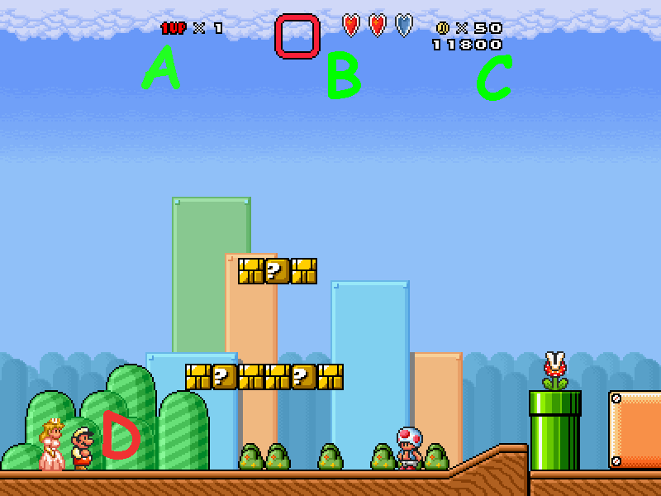
A - Lives
This shows the number of lives the players have remaining. Players share lives in two player mode. Upon Death, a player may press the jump button to be revived at the other players current location as long as there are lives available to be used.
B - Item Reserve OR Heart Containers
Item Reserve
Mario and Luigi may store items for use later. If Mario or Luigi gather an item less powerful or equally powerful than the power-up they are already using, their current power-up (or weaker obtained item) will be placed in the Reserve box for later use. Pressing the DROP ITEM button will make the item start to float towards the bottom of the screen, where either player may obtain it, regardless of who dropped it. These items will remain in this box until dropped or replaced, as they are not effected by damage or death. If Mario or Luigi are 'Small' and they are hurt, they will die.

Heart Containers
Peach, Toad and Link all have 3 hearts of health. Every Item they obtain will add one heart. Some items will also add special abilities to these three characters, but they may not store extra items for later like Mario and Luigi can. So be careful when gathering items, as you may overwrite a power-up you wanted to be using. Upon having 0 Hearts the player will die.
C - Points, Coins, Links Keys
Points - Every item and enemy kill will give the players points. These are only tracked for a players own personal tracking of achievements. They have no bearing on the gameplay itself.
Coins - Players in two player mode share coins gathered. Upon gathering 100 coins, the players will obtain 1 extra life.
KEYS - Link, upon obtaining a Key, will carry it here as if it is in an inventory. It will appear as a small key near the coin image.
D - The Players
The players will both always be visible on the screen at the same time. If the players separate in two player mode, the screen will automatically split allowing for free travel separate from each other. One player finishing a level will complete it, even if the other player is far away from the end.

2. Game Features

2.A Characters
Playable Characters - Each Playable Character has different gameplay styles. try them all and find the one you like the most. Or the one that will work best in certain situations.

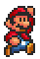
Mario
Speed - High Acceleration
Jump Height - Normal (Normal Fall Speed)
Secondary Jump = Spin Jump (Bounce off or destroy most harmful creatures.)
Hammer Suit Effect = Toss Hammers
Fire Flower Effect = Toss quick low bouncing fireballs that will 'poof' upon hitting a wall.
Ride = Yoshi, Shoes, Clown Car
Use Carry Weapons = Yes
Carry Objects = In Front of Him
Coin Block Effect = One coin instantly obtained at a time from the block per hit.
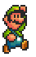
Luigi
Speed - Normal Acceleration
Jump Height - High (Low Fall Speed)
Secondary Jump = Spin Jump (Bounce off or destroy most harmful creatures.)
Hammer Suit Effect = Toss Hammers
Fire Flower Effect = Toss slow low bouncing fireballs that will 'poof' upon hitting a wall.
Ride = Yoshi, Shoes, Clown Car
Use Carry Weapons = Yes
Carry Objects = In Front of Him
Coin Block Effect = All coins emerges from block at once, must be grabbed as they scatter.

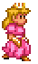
Peach
Speed - Low Acceleration
Jump Height - Normal (Normal Fall Speed)
Secondary Jump = Hold to Float (Pressing Normal Jump while already jumping floats too.)
Hammer Suit Effect = Toss Heart Bombs (Explode on Impact)
Fire Flower Effect = Toss fast high bouncing fireballs that will 'poof' upon hitting two walls
Ride = Shoes, Clown Car
Use Carry Weapons = Yes
Carry Objects = Over Her Head
Coin Block Effect = One coin instantly obtained at a time from the block per hit.

Other Notable Abilities - May Jump and float while still ducking. May toss
ice/fireballs straight up when pressing secondary run while
powered by an ice-flower or fire-flower.

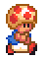
Toad
Speed - Very High Acceleration
Jump Height - Normal (Normal Fall Speed)
Secondary Jump = Spin Jump (Bounce off or destroy most harmful creatures.)
Hammer Suit Effect = Toss Boomerang (Returns to Toad, Gathers coins.)
Fire Flower Effect = Toss very fast low bouncing fireballs that will 'poof' upon hitting wall.
Ride = Shoes, Clown Car
Use Carry Weapons = Yes
Carry Objects = Over His Head
Coin Block Effect = Up to 5 coins pop out at a time and must be grabbed as they scatter.

Other Notable Abilities - May toss ice/fireballs straight up when pressing secondary
run while powered by an ice-flower or fire-flower.
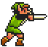
Link
Speed - Low Acceleration
Jump Height - Normal (Shorter Horizontal Distance) (Normal Fall Speed)
Secondary Jump = None (Pressing Down while jumping will make link stab downward.)
Hammer Suit Effect = Shadow Link (Links sword stab shoots a beam.)
Fire Flower Effect = Toss a straight flying fireball that will 'poof' upon hitting wall.
Ride = Clown Car
Use Carry Weapons = No
Carry Objects = No (May collect up to 9 Fuse Bombs to toss at enemy with ALT RUN.)
Coin Block Effect = 10 (max) rupees pop out at a time and must be grabbed as they scatter
Leaf Effect = Link may turn into a fairy and fly for a short duration.
Tanooki Effect = Link may turn into a fairy and fly for a short duration. And pressing Alt-run will make link turn into a suit of armour and be invulnerable for a short period.

Other Notable Abilities - May stab with his sword and destroy most enemies from the side. Fireballs hitting Links shield will 'poof' and not harm Link. When link kills and enemy with his sword, he may cause a rupee to appear. Link is the only character who can always hit a ? block from the side with his attack. Holding up while jumping will make link stab upwards and can destroy many destroy-able blocks at once.

2.B Items
These are the basic default items you will see in SMBX. But remember, any episode may contain altered or custom items not listed here as well.

Coins 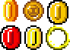
Coins have many variations of appearance, but all give you one coin. Red Coins have the special effect of being allowed to be eaten by Yoshi.

Blue Coins
Blue Coins give you 5 coins.

Rupees 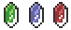
These will give you a number of coins depending on their color.
Green will give 1 coin.
Blue will give 5 coins.
Red will give 20 coins.

Yoshi Coins 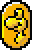
Collecting 5 or more of these in the same level will give you extra lives.

Super Mushroom (and Heart) 
Obtaining this will make you into a Super Character (or add one heart). A mushroom with a thin stem has the additional ability: obtaining it will make a copy of an active power-up into the reserve slot.

Fire Flower 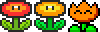
This will allow you to throw/toss fireballs at enemies. Unfreeze frozen enemies or items.

Ice Flower 
This will allow you to throw ice-balls at enemies, and freeze them. Once they are frozen, you may step onto the block, and then lift and toss it.

Hammer Brothers Suit (or Black Pendant)
Each character will gain a different power of the Hammer Bros. Mario and Luigi will toss hammers at enemies, Peach with throw bombs, Toad will toss a boomerang capable of gathering coins for him, and Link will be armed with a magical sword beam.

Leaf/Raccoon Tail
This will allow your character to fly if they get a running start. May also be used to spin around and whack enemies with your tail. Tap the jump button while falling to float safely to the ground. (Link will become Blue Link and be able to become a fairy to fly for a short duration.)

Tanooki Suit (or Gold Pendant) 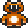
Has all the abilities of the Leaf/Raccoon Tail, but also gains the ability to press ALT RUN to become temporarily invulnerable as a statue.

1-Up Mushroom and 3-Up Moon 
Obtaining these will increase your lives by 1 from a mushroom, or by 3 if you collect a moon.

? Mushroom 
In Two player or Battle Mode, the players will swap positions if one obtains this mushroom.

Stop Watch / Green P Switch 
These will freeze time stopping all action besides player movement for a short duration.

Billy Gun 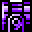
This may be carried. While carried it launches Bullet Bills at your enemies. Bullet bills will travel until hitting a wall. You can install it on a Clown Car and shoot with it using the “run” key.

Toothy Pipe 
Carrying this will hold it in front of you where a Piranha Plant will emerge and eat any enemies that you want it to. It also can be installed on a Clown Car and used with the “run” key to emerging the Toothy from the pipe.

POW Block 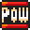
May be tossed to kill all enemies on the screen. It may also dislodge many stationary items, such as coins and cause them to fall to the ground and roll about.

Fuse Bombs and Bob-ombs 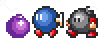
These may be tossed at enemies. Depending on the Bomb type, they may explode on enemy contact or burn off a fuse and then explode. Link may stab at the Fuse Bombs to gather and carry up to 9 of these. He may then toss them by pressing ALT RUN. Stabbing a Bob-omb however will make them explode.

Burred Items
These items may be pulled from the ground. It could be anything really. If you pull an enemy from the ground, it will be friendly to you. Some will even attack your enemies held. Be careful, Some will become your enemy however, once you drop or toss them.

Bubbled Items 
These items float along aimlessly until they collide with something. When the collision happens, the bubble pops and you must chase the item that was inside. Unless it was an enemy, then its probably chasing you.

Warp Potions 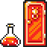
These will open doorways to secret areas when tossed.

Mushroom Capsules 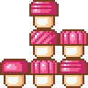
These may be tossed at enemies to harm them, or stacked up to help you reach an area you can't normally. Also, you can put them on a dangerous surface to pass it safely.

Yoshi Eggs
These may be tossed to be opened, What is inside?! You'll have to check.

Blue P Switch 
When activated, some blocks will turn into coins, and coins will turn into blocks. And depending on the situation, a secret door may appear. Use it wisely: sometimes, a mistake can be fatal.

Blue Pendant
Will turn you into a fairy until you come to rest on solid ground again. Touching an enemy, their projectiles, or any dangerous surfaces also will remove this effect.

Star 
These are collected to end a level, or are gathered to open doors that may require a certain number of stars.

Propeller Block 
Holding this will allow you to jump much higher if you hold up while jumping. Also will allow you to float safely to the ground at a much slower rate.

Propeller Block Flamethrower 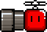
Has all the same effects as the Propeller Block, but this will shoot fireballs constantly at your enemies. The fireballs will pass through all objects, including walls and blocks.

Trampoline 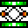
This may be carried to a point you may need it. Jumping on it will propel the jumper high into the air so they may reach normally unreachable areas.

Rainbow Shell
This flashing shell may be tossed at your enemies without the worry of harming your fellow player or yourself. You can ride them if you make the running start, then jump, then pressing the “down” key, and then, releasing the shell. You can get off the shell when you press the “alt-jump” button.

Keys 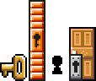
Carrying a Key to a Door with a keyhole will open it. If a key is stabbed by Link he will carry it in a special holder until he touches a door. Bringing a key to the lonely door-less keyhole will complete the level.

Yoshis 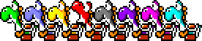
Each colour Yoshi has its own effects while being ridden by Mario or Luigi. All Yoshis allow Mario To leap off him while jumping to reach higher areas, or save his own life. And all Yoshi may swallow enemies, spit shells and carry the other player in its mouth. Yoshi will allow the player to walk over some dangerous grounds, and bounce off some dangerous enemies.
- Green – No special effects
- Blue – May fly for short bursts if carrying something in its mouth.
- Yellow – Creates a STOMP effect on landing if holding something in its mouth.
- Red – Will turn shells into fire balls when they are spit out.
- Black – Has all of the abilities of the RED, YELLOW, and BLUE Yoshi's at once.
- Purple – Allows for holding down to STOMP and break blocks below.
- Pink – All swallowed enemies become vegetables when spit out again.
- Teal – All spit enemies become ice blocks that slide until hitting something.

Boots 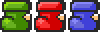
Each boot offered its rider a different ability besides also jumping higher.
- Green - Lets the player walk over dangerous spikes or chompers.
- Red - Lets the player walk on Lava
- Blue - Allows the player infinite flight.
Clown Car 
Jumping onto this and pressing down will let you drive this and fly around at will. Landing on enemies from above will kill them.
Coloured Switch Blocks 
You will happen upon coloured Question Blocks that when activated will turn ! blocks passable, or impassable.
Player Blocks
When hitting a letter block, you will become the corresponding character. The coloured ! blocks will only let that character pass through them.

2.C Major Enemies
The following Bosses may be fought along your journey!
Most Bosses can be hurt by Fire Balls or Hammers as well as tossed items.

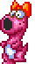
Birdo
Birdo will spit eggs at you, and you must catch them mid-air and toss them back at Birdo. Unless other nearby objects are available to be tossed. Three hits usually ends this Bosses reign.

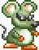
Mouser
Mouser will toss bombs are the player continuously. Toss the bombs back at him to finish him off. Four Bombs will usually finish him off.

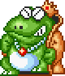
Wart
This indigestion prone Toad will spit bubbles at you. You must toss objects into his mouth when he does to harm him. Six bad meals will usually end him.

Boom-Boom
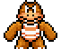
This big bully will rush at you and try to hit you with his fists. Jump on his head three times to defeat him. Be careful however, occasionally he will throw out his spikes to prevent being jumped on.

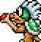
Larry Koopa
Larry likes magic, and he attacks you with a magic wand. Jump on his head three times to defeat him. Be careful, when you jump on his head, he spins at you in his shell for a moment.

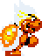
Ludwig Koopa
He likes spicy foods and will spit fire at you, while occasionally spinning in his shell and then flipping head over heals to try and land on you. Jump on his head three times while he is not in his shell to finish him.

Bowser
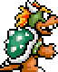
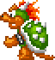
Bowser has two separate battle types. One will toss hammers and spit fire at you. The other will hop up and down while spitting fire at you. He will then jump high into the air and attempt to crush you when he lands. Both can only be defeated with tossed items or power-ups. you will have to hit him many times before he will fall depending on the weapon or power-up you use.

3. Copyright
This project is a fan game developed by enthusiasts and is not affiliated or endorsed by Nintendo.
All trademarks for Super Mario Bros. And Nintendo belong to their respective owners.
All rights to Nintendo Characters and themes are held by Nintendo.
Please show you support of Nintendo by purchasing Nintendo Games and Game systems.

Game Manual originally Written and updated for each version
by member "Blue" (Jeremy Guerrette)
Updated by “Wohlstand” in favour of TheXTech build of SMBX game.

It’s possible to build the game for Mac OS X Tiger with PowerPC processor using the Tigerbrew toolchain and the special version of the SDL2 library.
It's possible to run the game using 64 MB video card if you change the “scale-mode” option of the “[video]” section to the “all” value at the “settings/thextech.ini” settings file.
User Directory (opposed to read-only Assets Directory) is the writeable directory where you can find game settings, logs, user-provided battle levels and episodes, and saved games. At portable packages, this is the same directory as Assets Directory. On macOS, the User Directory appears in the User’s home directory, at the “TheXTech Games/<game name>/” sub-directory which gets auto-created on a first launch of the game.
For the Purple Yoshi stomp, the DOWN key can be reconfigured to use the ALT-RUN key instead.

